**National Charitable Organization**

**Alessio Fois**

***Machine Learning Project***

**Table of Contents**

***Business Objectives:*** 2

***Machine Learning Project’s Purpose:*** 2

***Machine Learning Project’s Goal:*** 2

***Data Description and Data Quality:*** 2

Donor Raw Data_ML with Python.csv 2

Prospective Donor_ML with Python.csv 5

***Data Exploration:*** 9

Statistics for Donor Raw Data_ML with Python.csv 9

Correlations between the numerical features before Data Preparation 10

Data Distributions (Histograms) 12

Data Distributions (Histograms)  - After Data Preparation 13

TARGET_B distribution 13

# Business Objectives:

Philanthropy and social well-being.

# Machine Learning Project’s Purpose:

The machine learning project’s purpose is to use the results of a previous postcard mail solicitation for donations to deliver actionable insight and to improve the outcome in the next campaign.

# Machine Learning Project’s Goal:

The machine learning project’s goal is to determine which of the individuals in the National Charitable Organisation mailing database have characteristics similar to their most profitable donors. By soliciting only these people, the Organisation can spend less money on the solicitation effort and more money on charitable concerns.

# Data Description and Data Quality:

Data provided are two csv files:

1. Donor Raw Data_ML with Python.csv (Historical Data)
2. Prospective Donor_ML with Python.csv (New Contact List)

## Donor Raw Data_ML with Python.csv

Data shape: 19372 rows, 50 features (columns).

|  |  |  |  |  |  |  |  |
| --- | --- | --- | --- | --- | --- | --- | --- |
| **Feature** | **Description** | **Data type object** | **Type** | **Missing Values** | **Missing Values %** | **Note** | **Action** |
| TARGET_B | Response to 97NK solicitation (1=yes, 0=no) | int64 | Binary | 0 | 0% |  |  |
| TARGET_D | Response amount to 97NK solicitation (missing if no response) | float64 | Continuous | 14529 | 75% | to drop | Dropped |
| CONTROL_NUMBER | The control number uniquely identifies each member of the analysis population | int64 | Continuous | 0 | 0% |  | Dropped |
| MONTHS_SINCE_ORIGIN | This number is derived from MONTHS_SINCE_FIRST | int64 | Continuous | 0 | 0% |  |  |
| DONOR_AGE | Age as of June 1997 | float64 | Continuous | 4795 | 25% | to fix | Missing values filled with the median |
| IN_HOUSE | A final field identifies donors who are part of the organization's In-House program | int64 | Binary | 0 | 0% |  |  |
| URBANICITY | U=Urban C=City S=Suburban T=Town R=Rural ?=Unknown | object | Categorical | 0 | 0% | 454 ? as Unknown | Replaced letters with numbers: C=6, T=5, U=4, S=3, R=2, ?=1 |
| SES | 5 socio-economic cluster codes | object | Categorical | 0 | 0% | 454 ? Which can be the socio-economic cluster codes = 5 | Replaced '?' with number 5, converted str to int |
| CLUSTER_CODE | 54 socio-economic cluster codes | object | Categorical | 0 | 0% | 454 ' .' ( a space followed by a point) which can be the socio-economic cluster codes = 54 | Replaced ' .' with number 54, converted str to int |
| HOME_OWNER | H=Homeowner U=Unknown | object | Categorical | 0 | 0% | 8766 unknowns = 45% | Dropped |
| DONOR_GENDER | Actual or inferred gender | object | Categorical | 0 | 0% | A=1 , U=1017, F = 10401, M=7953 | 1. Dropped rows with gender inputted wrongly 2. Replaced gender values with 1 for female, 0 for male with a categorical encoding |
| INCOME_GROUP | 7 income group levels | float64 | Ordinal | 4392 | 23% | to drop | Dropped |
| PUBLISHED_PHONE | Indicator of presence of published telephone listing | int64 | Binary | 0 | 0% |  |  |
| OVERLAY_SOURCE | M=Metromail P=Polk B=Both | object | Categorical | 0 | 0% | M=1480, P=4768, B=8732, N=4392 | Dropped |
| MOR_HIT_RATE | Total number of known times the donor has responded to a mail order offer other than the national charitable organization's. | int64 | Continuous | 0 | 0% |  |  |
| WEALTH_RATING | 10 wealth rating groups | float64 | Ordinal | 8810 | 45% |  | Dropped |
| MEDIAN_HOME_VALUE | Median home value in $100's | int64 | Continuous | 0 | 0% |  |  |
| MEDIAN_HOUSEHOLD_INCOME | Median household income in $100's | int64 | Continuous | 0 | 0% |  |  |
| PCT_OWNER_OCCUPIED | Percent of owner-occupied housing | int64 | Continuous | 0 | 0% |  |  |
| PER_CAPITA_INCOME | Per capita income in dollars | int64 | Continuous | 0 | 0% |  |  |
| PCT_ATTRIBUTE1 | Percent with attribute1 in the block | int64 | Continuous | 0 | 0% |  |  |
| PCT_ATTRIBUTE2 | Percent with attribute2 in the block | int64 | Continuous | 0 | 0% |  |  |
| PCT_ATTRIBUTE3 | Percent with attribute3 in the block | int64 | Continuous | 0 | 0% |  |  |
| PCT_ATTRIBUTE4 | Percent with attribute4 in the block | int64 | Continuous | 0 | 0% |  |  |
| PEP_STAR | STAR-status ever (1=yes, 0=no) | int64 | Binary | 0 | 0% |  |  |
| RECENT_STAR_STATUS | STAR (1,0) status since June 1994 | int64 | Binary | 0 | 0% |  |  |
| RECENCY_STATUS_96NK | Recency status as of June 1996 | object | Categorical | 0 | 0% | A' 'E' 'F' 'L' 'N' 'S' | Replaced letters with numbers: A=1, E=2, F=3, L=4, N=5, S=6 |
| FREQUENCY_STATUS_97NK | Frequency status as of June 1997 | int64 | Continuous | 0 | 0% |  |  |
| RECENT_RESPONSE_PROP | Response proportion since June 1994 | float64 | Continuous | 0 | 0% |  |  |
| RECENT_AVG_GIFT_AMT | Average gift amount since June 1994 | float64 | Continuous | 0 | 0% |  |  |
| RECENT_CARD_RESPONSE_PROP | Response proportion since June 1994 | float64 | Continuous | 0 | 0% |  |  |
| RECENT_AVG_CARD_GIFT_AMT | Average gift amount to card promotions since June 1994 | float64 | Continuous | 0 | 0% |  |  |
| RECENT_RESPONSE_COUNT | Response count since June 1994 | int64 | Continuous | 0 | 0% |  |  |
| RECENT_CARD_RESPONSE_COUNT | Response count since June 1994 | int64 | Continuous | 0 | 0% |  |  |
| MONTHS_SINCE_LAST_PROM_RESP | Number of months since donor has responded to a promotion date from June 1997 | float64 | Continuous | 246 | 1% |  | Missing values filled with the mean |
| LIFETIME_CARD_PROM | Total number of card promotions received | int64 | Continuous | 0 | 0% |  |  |
| LIFETIME_PROM | Total number of promotions received | int64 | Continuous | 0 | 0% |  |  |
| LIFETIME_GIFT_AMOUNT | Total gift amount given | float64 | Continuous | 0 | 0% |  |  |
| LIFETIME_GIFT_COUNT | Total number donations given | int64 | Continuous | 0 | 0% |  |  |
| LIFETIME_AVG_GIFT_AMT | Overall average gift amount | float64 | Continuous | 0 | 0% |  |  |
| LIFETIME_GIFT_RANGE | Maximum less minimum gift amount | float64 | Continuous | 0 | 0% |  |  |
| LIFETIME_MAX_GIFT_AMT | Maximum gift amount | float64 | Continuous | 0 | 0% |  |  |
| LIFETIME_MIN_GIFT_AMT | Minimum gift amount | float64 | Continuous | 0 | 0% |  |  |
| LAST_GIFT_AMT | Amount of most recent donation | float64 | Continuous | 0 | 0% |  |  |
| CARD_PROM_12 | Number of card promotions received in the last 12 months | int64 | Continuous | 0 | 0% |  |  |
| NUMBER_PROM_12 | Number of promotions received in the last 12 months | int64 | Continuous | 0 | 0% |  |  |
| MONTHS_SINCE_LAST_GIFT | Last donation date from June 1997 | int64 | Continuous | 0 | 0% |  |  |
| MONTHS_SINCE_FIRST_GIFT | First donation date from June 1997 | int64 | Continuous | 0 | 0% |  |  |
| FILE_AVG_GIFT | Average gift from raw data | float64 | Continuous | 0 | 0% |  |  |
| FILE_CARD_GIFT | Average card gift from raw data | int64 | Continuous | 0 | 0% |  |  |

## Prospective Donor_ML with Python.csv

Data shape: 2148 rows, 48 features (columns).

|  |  |  |  |  |  |  |  |
| --- | --- | --- | --- | --- | --- | --- | --- |
| **Feature** | **Description** | **Data type object** | **Type** | **Missing Values** | **Missing Values %** | **Note** | **Action** |
| CONTROL_NUMBER | The control number uniquely identifies each member of the analysis population | int64 | Continuous | 0 | 0% |  |  |
| MONTHS_SINCE_ORIGIN | This number is derived from MONTHS_SINCE_FIRST | int64 | Continuous | 0 | 0% |  |  |
| DONOR_AGE | Age as of June 1997 | float64 | Continuous | 529 | 25% | to fix | Missing values filled with the median |
| IN_HOUSE | A final field identifies donors who are part of the organization's In-House program | int64 | Binary | 0 | 0% |  |  |
| URBANICITY | U=Urban C=City S=Suburban T=Town R=Rural ?=Unknown | object | Categorical | 0 | 0% | "?" as Unknown | Replaced letters with numbers: C=6, T=5, U=4, S=3, R=2, ?=1 |
| SES | 5 socio-economic cluster codes | object | Categorical | 0 | 0% | "?" Which can be the socio-economic cluster codes = 5 | Replaced '?' with number 5, converted str to int |
| CLUSTER_CODE | 54 socio-economic cluster codes | object | Categorical | 0 | 0% | " ." ( a space followed by a point) which can be the socio-economic cluster codes = 54 | Replaced ' .' with number 54, converted str to int |
| HOME_OWNER | H=Homeowner U=Unknown | object | Categorical | 0 | 0% |  | Dropped |
| DONOR_GENDER | Actual or inferred gender | object | Categorical | 0 | 0% | U, F, M | 1. Dropped rows with gender inputted wrongly 2. Replaced gender values with 1 for female, 0 for male with a categorical encoding |
| INCOME_GROUP | 7 income group levels | float64 | Ordinal | 481 | 22% |  | Dropped |
| PUBLISHED_PHONE | Indicator of presence of published telephone listing | int64 | Binary | 0 | 0% |  |  |
| OVERLAY_SOURCE | M=Metromail P=Polk B=Both | object | Categorical | 0 | 0% | M=1480, P=4768, B=8732, N=4392 | Dropped |
| MOR_HIT_RATE | Total number of known times the donor has responded to a mail order offer other than the national charitable organization's. | int64 | Continuous | 0 | 0% |  |  |
| WEALTH_RATING | 10 wealth rating groups | float64 | Ordinal | 1006 | 47% |  | Dropped |
| MEDIAN_HOME_VALUE | Median home value in $100's | int64 | Continuous | 0 | 0% |  |  |
| MEDIAN_HOUSEHOLD_INCOME | Median household income in $100's | int64 | Continuous | 0 | 0% |  |  |
| PCT_OWNER_OCCUPIED | Percent of owner-occupied housing | int64 | Continuous | 0 | 0% |  |  |
| PER_CAPITA_INCOME | Per capita income in dollars | int64 | Continuous | 0 | 0% |  |  |
| PCT_ATTRIBUTE1 | Percent with attribute1 in the block | int64 | Continuous | 0 | 0% |  |  |
| PCT_ATTRIBUTE2 | Percent with attribute2 in the block | int64 | Continuous | 0 | 0% |  |  |
| PCT_ATTRIBUTE3 | Percent with attribute3 in the block | int64 | Continuous | 0 | 0% |  |  |
| PCT_ATTRIBUTE4 | Percent with attribute4 in the block | int64 | Continuous | 0 | 0% |  |  |
| PEP_STAR | STAR-status ever (1=yes, 0=no) | int64 | Binary | 0 | 0% |  |  |
| RECENT_STAR_STATUS | STAR (1,0) status since June 1994 | int64 | Binary | 0 | 0% |  |  |
| RECENCY_STATUS_96NK | Recency status as of June 1996 | object | Categorical | 0 | 0% | A' 'E' 'F' 'L' 'N' 'S' | Replaced letters with numbers: A=1, E=2, F=3, L=4, N=5, S=6 |
| FREQUENCY_STATUS_97NK | Frequency status as of June 1997 | int64 | Continuous | 0 | 0% |  |  |
| RECENT_RESPONSE_PROP | Response proportion since June 1994 | float64 | Continuous | 0 | 0% |  |  |
| RECENT_AVG_GIFT_AMT | Average gift amount since June 1994 | float64 | Continuous | 0 | 0% |  |  |
| RECENT_CARD_RESPONSE_PROP | Response proportion since June 1994 | float64 | Continuous | 0 | 0% |  |  |
| RECENT_AVG_CARD_GIFT_AMT | Average gift amount to card promotions since June 1994 | float64 | Continuous | 0 | 0% |  |  |
| RECENT_RESPONSE_COUNT | Response count since June 1994 | int64 | Continuous | 0 | 0% |  |  |
| RECENT_CARD_RESPONSE_COUNT | Response count since June 1994 | int64 | Continuous | 0 | 0% |  |  |
| MONTHS_SINCE_LAST_PROM_RESP | Number of months since donor has responded to a promotion date from June 1997 | float64 | Continuous | 26 | 1% |  | Missing values filled with the mean |
| LIFETIME_CARD_PROM | Total number of card promotions received | int64 | Continuous | 0 | 0% |  |  |
| LIFETIME_PROM | Total number of promotions received | int64 | Continuous | 0 | 0% |  |  |
| LIFETIME_GIFT_AMOUNT | Total gift amount given | float64 | Continuous | 0 | 0% |  |  |
| LIFETIME_GIFT_COUNT | Total number donations given | int64 | Continuous | 0 | 0% |  |  |
| LIFETIME_AVG_GIFT_AMT | Overall average gift amount | float64 | Continuous | 0 | 0% |  |  |
| LIFETIME_GIFT_RANGE | Maximum less minimum gift amount | float64 | Continuous | 0 | 0% |  |  |
| LIFETIME_MAX_GIFT_AMT | Maximum gift amount | float64 | Continuous | 0 | 0% |  |  |
| LIFETIME_MIN_GIFT_AMT | Minimum gift amount | float64 | Continuous | 0 | 0% |  |  |
| LAST_GIFT_AMT | Amount of most recent donation | float64 | Continuous | 0 | 0% |  |  |
| CARD_PROM_12 | Number of card promotions received in the last 12 months | int64 | Continuous | 0 | 0% |  |  |
| NUMBER_PROM_12 | Number of promotions received in the last 12 months | int64 | Continuous | 0 | 0% |  |  |
| MONTHS_SINCE_LAST_GIFT | Last donation date from June 1997 | int64 | Continuous | 0 | 0% |  |  |
| MONTHS_SINCE_FIRST_GIFT | First donation date from June 1997 | int64 | Continuous | 0 | 0% |  |  |
| FILE_AVG_GIFT | Average gift from raw data | float64 | Continuous | 0 | 0% |  |  |
| FILE_CARD_GIFT | Average card gift from raw data | int64 | Continuous | 0 | 0% |  |  |

# Data Exploration:

## Statistics for Donor Raw Data_ML with Python.csv

|  |  |  |  |  |  |  |  |  |
| --- | --- | --- | --- | --- | --- | --- | --- | --- |
| **Features** | **Count** | **Mean** | **Std** | **Min** | **25%** | **50%** | **75%** | **Max** |
| TARGET_B | 19372 | 0.25 | 0.43 | 0 | 0 | 0 | 0.25 | 1 |
| TARGET_D | 4843 | 15.62 | 12.45 | 1 | 10 | 13 | 20 | 200 |
| CONTROL_NUMBER | 19372 | 96546.23 | 55830.64 | 5 | 48289 | 96937 | 145429.5 | 191779 |
| MONTHS_SINCE_ORIGIN | 19372 | 73.41 | 41.26 | 5 | 29 | 65 | 113 | 137 |
| DONOR_AGE | 14577 | 58.92 | 16.67 | 0 | 47 | 60 | 73 | 87 |
| IN_HOUSE | 19372 | 0.07 | 0.26 | 0 | 0 | 0 | 0 | 1 |
| INCOME_GROUP | 14980 | 3.91 | 1.86 | 1 | 2 | 4 | 5 | 7 |
| PUBLISHED_PHONE | 19372 | 0.50 | 0.50 | 0 | 0 | 0 | 1 | 1 |
| MOR_HIT_RATE | 19372 | 3.36 | 9.50 | 0 | 0 | 0 | 3 | 241 |
| WEALTH_RATING | 10562 | 5.01 | 2.82 | 0 | 3 | 5 | 7 | 9 |
| MEDIAN_HOME_VALUE | 19372 | 1079.87 | 960.75 | 0 | 518 | 747 | 1227 | 6000 |
| MEDIAN_HOUSEHOLD_INCOME | 19372 | 341.97 | 164.21 | 0 | 232 | 311 | 417 | 1500 |
| PCT_OWNER_OCCUPIED | 19372 | 69.70 | 21.71 | 0 | 60 | 76 | 85 | 99 |
| PER_CAPITA_INCOME | 19372 | 15857.33 | 8710.63 | 0 | 10869 | 13816.5 | 18308.25 | 174523 |
| PCT_ATTRIBUTE1 | 19372 | 1.03 | 4.92 | 0 | 0 | 0 | 0 | 97 |
| PCT_ATTRIBUTE2 | 19372 | 30.57 | 11.42 | 0 | 25 | 31 | 37 | 99 |
| PCT_ATTRIBUTE3 | 19372 | 29.60 | 15.12 | 0 | 20 | 29 | 39 | 99 |
| PCT_ATTRIBUTE4 | 19372 | 32.85 | 17.84 | 0 | 21 | 32 | 43 | 99 |
| PEP_STAR | 19372 | 0.50 | 0.50 | 0 | 0 | 1 | 1 | 1 |
| RECENT_STAR_STATUS | 19372 | 0.93 | 2.55 | 0 | 0 | 0 | 1 | 22 |
| FREQUENCY_STATUS_97NK | 19372 | 1.98 | 1.10 | 1 | 1 | 2 | 3 | 4 |
| RECENT_RESPONSE_PROP | 19372 | 0.19 | 0.11 | 0 | 0.105 | 0.167 | 0.25 | 1 |
| RECENT_AVG_GIFT_AMT | 19372 | 15.37 | 10.17 | 0 | 10 | 14 | 20 | 260 |
| RECENT_CARD_RESPONSE_PROP | 19372 | 0.23 | 0.19 | 0 | 0.1 | 0.2 | 0.333 | 1 |
| RECENT_AVG_CARD_GIFT_AMT | 19372 | 11.69 | 10.83 | 0 | 5 | 10.14 | 16 | 300 |
| RECENT_RESPONSE_COUNT | 19372 | 3.04 | 2.05 | 0 | 2 | 3 | 4 | 16 |
| RECENT_CARD_RESPONSE_COUNT | 19372 | 1.73 | 1.54 | 0 | 1 | 1 | 2 | 9 |
| MONTHS_SINCE_LAST_PROM_RESP | 19126 | 19.04 | 3.42 | -12 | 17 | 18 | 21 | 36 |
| LIFETIME_CARD_PROM | 19372 | 18.67 | 8.56 | 2 | 11 | 18 | 26 | 56 |
| LIFETIME_PROM | 19372 | 47.57 | 22.95 | 5 | 28 | 47 | 64 | 194 |
| LIFETIME_GIFT_AMOUNT | 19372 | 104.43 | 105.72 | 15 | 42 | 79 | 132 | 3775 |
| LIFETIME_GIFT_COUNT | 19372 | 9.98 | 8.69 | 1 | 4 | 8 | 14 | 95 |
| LIFETIME_AVG_GIFT_AMT | 19372 | 12.86 | 8.79 | 1.36 | 8 | 11.2 | 15 | 450 |
| LIFETIME_GIFT_RANGE | 19372 | 11.59 | 15.12 | 0 | 5 | 10 | 15 | 997 |
| LIFETIME_MAX_GIFT_AMT | 19372 | 19.21 | 16.10 | 5 | 12 | 16 | 21 | 1000 |
| LIFETIME_MIN_GIFT_AMT | 19372 | 7.62 | 7.96 | 0 | 3 | 5 | 10 | 450 |
| LAST_GIFT_AMT | 19372 | 16.58 | 11.98 | 0 | 10 | 15 | 20 | 450 |
| CARD_PROM_12 | 19372 | 5.37 | 1.26 | 0 | 5 | 6 | 6 | 17 |
| NUMBER_PROM_12 | 19372 | 12.90 | 4.64 | 2 | 11 | 12 | 13 | 64 |
| MONTHS_SINCE_LAST_GIFT | 19372 | 18.19 | 4.03 | 4 | 16 | 18 | 20 | 27 |
| MONTHS_SINCE_FIRST_GIFT | 19372 | 69.48 | 37.57 | 15 | 33 | 65 | 105 | 260 |
| FILE_AVG_GIFT | 19372 | 12.86 | 8.79 | 1.36 | 8 | 11.2 | 15 | 450 |
| FILE_CARD_GIFT | 19372 | 5.27 | 4.61 | 0 | 2 | 4 | 8 | 41 |

## Correlations between the numerical features before Data Preparation

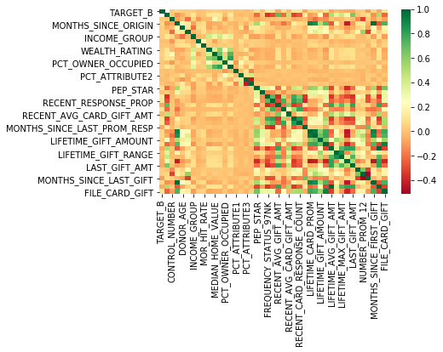

|  |
| --- |
| **Correlation between Target_B and Features** |
| TARGET_B 1.000000 |
| FREQUENCY_STATUS_97NK 0.137343 |
| RECENT_RESPONSE_COUNT 0.128762 |
| RECENT_CARD_RESPONSE_COUNT 0.126241 |
| RECENT_RESPONSE_PROP 0.118343 |
| FILE_CARD_GIFT 0.105552 |
| PEP_STAR 0.105389 |
| RECENT_CARD_RESPONSE_PROP 0.100902 |
| LIFETIME_GIFT_COUNT 0.100018 |
| LIFETIME_PROM 0.067846 |
| MONTHS_SINCE_FIRST_GIFT 0.066514 |
| LIFETIME_CARD_PROM 0.065585 |
| MONTHS_SINCE_ORIGIN 0.062795 |
| MEDIAN_HOME_VALUE 0.050377 |
| PER_CAPITA_INCOME 0.041528 |
| LIFETIME_GIFT_AMOUNT 0.041378 |
| IN_HOUSE 0.040964 |
| NUMBER_PROM_12 0.039967 |
| INCOME_GROUP 0.039932 |
| CARD_PROM_12 0.038947 |
| MEDIAN_HOUSEHOLD_INCOME 0.038190 |
| DONOR_AGE 0.036949 |
| WEALTH_RATING 0.034742 |
| CONTROL_NUMBER 0.024607 |
| PCT_OWNER_OCCUPIED 0.015720 |
| MOR_HIT_RATE 0.012689 |
| PCT_ATTRIBUTE4 0.010067 |
| PCT_ATTRIBUTE2 0.008815 |
| RECENT_STAR_STATUS -0.001475 |
| PUBLISHED_PHONE -0.003219 |
| PCT_ATTRIBUTE1 -0.003648 |
| LIFETIME_GIFT_RANGE -0.006354 |
| PCT_ATTRIBUTE3 -0.010106 |
| RECENT_AVG_CARD_GIFT_AMT -0.016935 |
| LIFETIME_MAX_GIFT_AMT -0.036990 |
| LIFETIME_MIN_GIFT_AMT -0.062756 |
| MONTHS_SINCE_LAST_PROM_RESP -0.066744 |
| FILE_AVG_GIFT -0.067107 |
| LIFETIME_AVG_GIFT_AMT -0.067107 |
| LAST_GIFT_AMT -0.068220 |
| RECENT_AVG_GIFT_AMT -0.074668 |
| MONTHS_SINCE_LAST_GIFT -0.089854 |
| TARGET_D NaN |

## Data Distributions (Histograms)

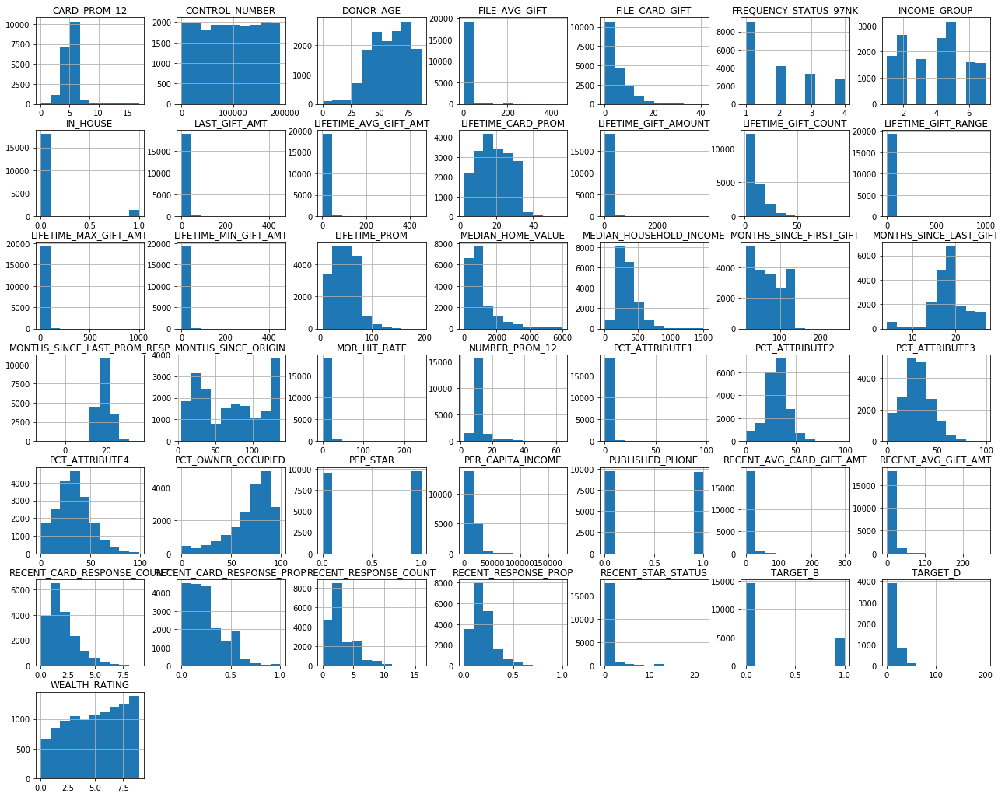

## Data Distributions (Histograms)  - After Data Preparation

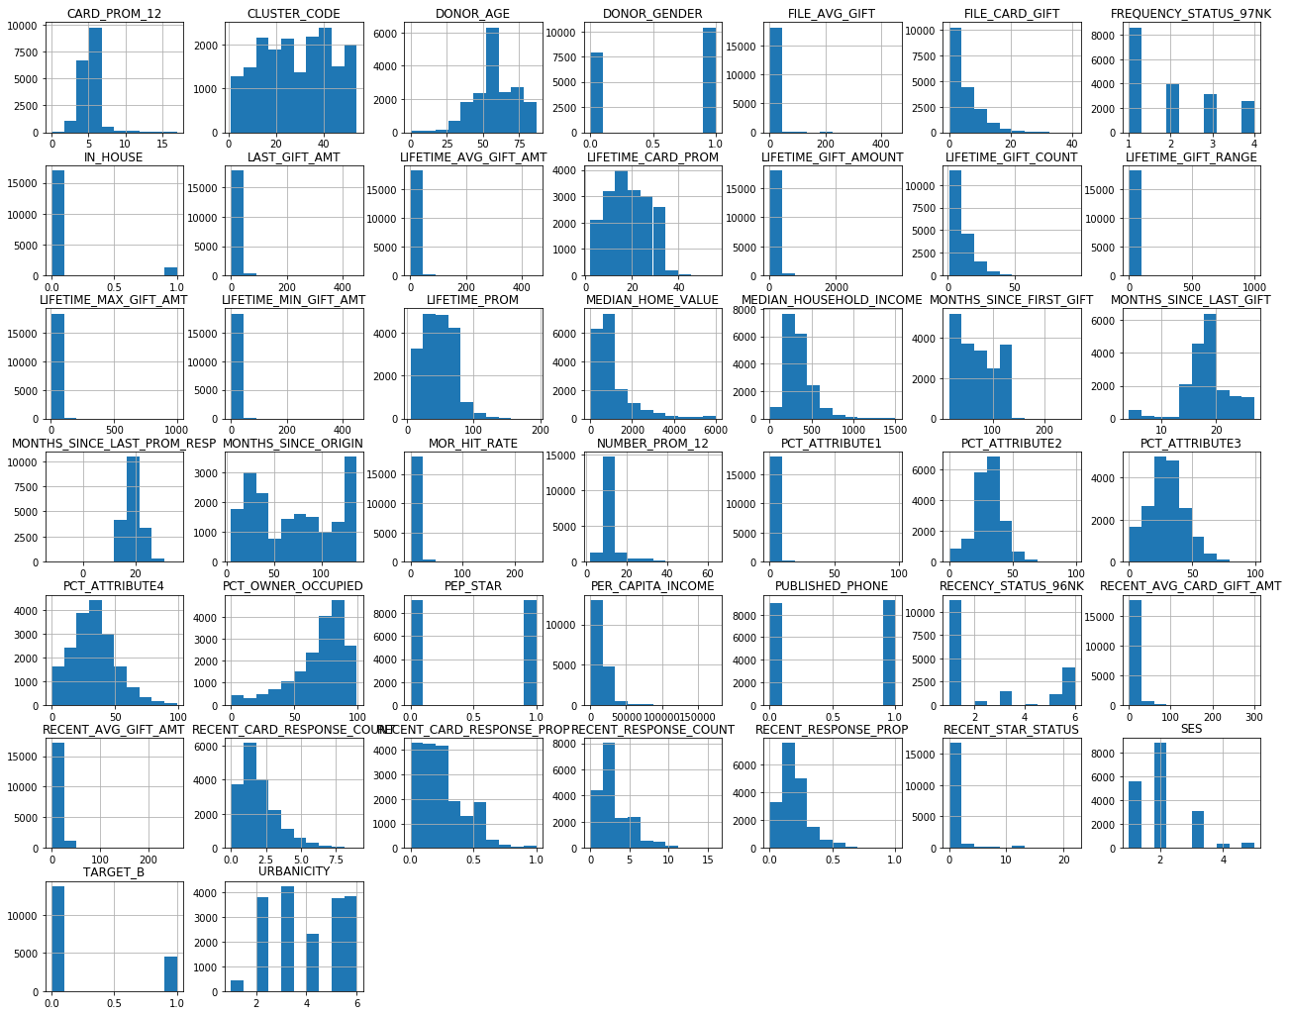

## TARGET_B distribution

